**CHAPTER III**

**METHODOLOGY**

**INPUT PROCESS OUTPUT**

**Knowledge Requirements**

1. Manuel Rojas Elementary School (MRES)

1.1 Background

1. Computer Based Information System
   1. Introduction of CBIS
   2. Importance of CBIS

2.3Advantage and Disadvantage of CBIS

1. Form 137

3.1 What is Form 137?

3.2 Purpose of Form 137.

1. Student Promotion

4.1 What is Student Promotion?

4.2 Purpose of Student Promotion.

1. Security

5.1 Security Purpose

5.2 Password

1. Programming Language

6.1 Visual Basic 6.0

6.2 My SQL

1. Evaluation

7.1 ISO9126

**Software Requirements**

1. Visual Basic 6.0
2. My SQL

**Hardware Requirements**

1. Computer Set

* Atleast 1GB RAM
* Atleast Pentium 4

1. Printer

COMPUTERIZED FORM 137 AND STUDENT PROMOTION OF MANUEL S. ROJAS ELEMENTARY SCHOOL

System Design

System Development

System Testing & Revision

EVALUATION

**Figure 1.** Conceptual Model of the Study

The conceptual model illustrated on figure 1 shows the different stages of process for the development of system. A proposed system consists of Input, Process and Output.

The input stage consists of the knowledge requirement such as the history of Manuel S. Rojas Elementary School, Introduction of Computer Based Information System, its importance and its advantages and disadvantages. It also includes the Form 137 itself and its purpose as well as the Student Promotion and its purpose too. It includes the security and evaluation system also. For software requirement the researcher use the Visual Basic 6.0 as programming language and My SQL for database. Hardware requirements consist of a computer set with minimum specifications of Pentium 4 and 1 GB of RAM and a printer.

The second is the process of the study that contains of system design, system development and thesystem testing and revision. System design it consists of plan and design of the system software. System development consists of steps for creating the system or flowcharting and the design of the user interface in order to complete the requirements needed. The system testing and revision will be tested to know if the system is working properly and to reduce errors that may arise in the system.

The third is the output of the study is the “Computerized Form 137 and Student Promotion of Manuel S. Rojas Elementary School” the ISO 9126 will be used to evaluate the system capabilities.

**Project Development**

The system will be developed through the use of Visual Basic 6.0 for front-end and Microsoft Access for its back-end.

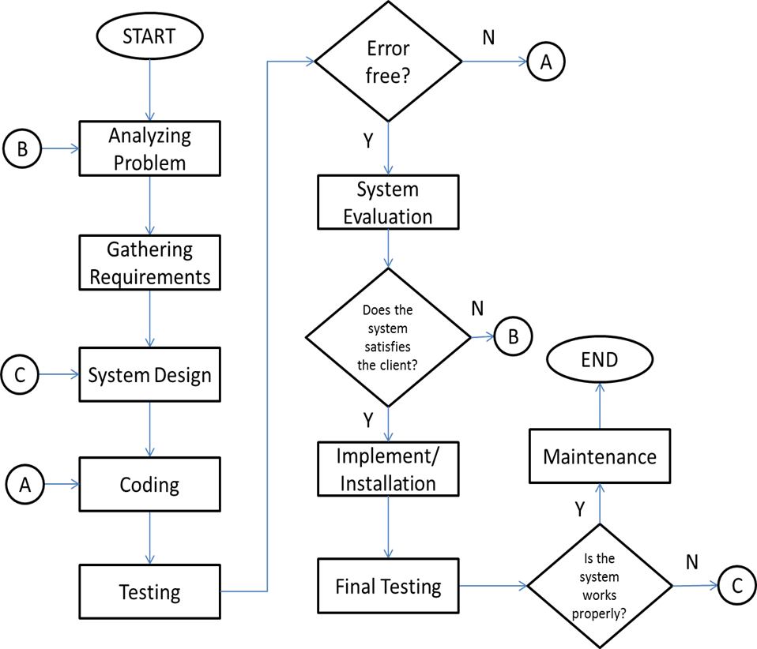

**Figure 2.**Project Development of Computerized Form 137 and Student Promotion of Manuel S. Rojas Elementary School

In Figure 2 it shows the steps conducted by the researchers to develop the project. To start with, the researchers analyze the problems encountered by the client. The next step is to gather the requirements needed to build the system. Based on the information gathered the design of the system can now be identified. After designing the system it will now be coded and tested if errors occur, it will go back and check on coding if not, the system will be evaluated. If the client not satisfied to the system the researchers will analyze again the problem, but if the client satisfied it will now implemented and will undergo final testing. If the system encountered problem, the researchers repeat the design stage until the system works properly and maintain the system.

**Operation and Testing Procedure**

1. The system will be installed and the complete process will be followed.
2. The user will input the grades of the student to be added to the system.
3. The user must save the inputted data.
4. The admin can view, delete, and print the form 137 or the promotion record.
5. The result will be able to print in Microsoft Excel.

**Evaluation Procedure**

The proposed system will be demonstrated to the principal and guidance counselor of Manuel Rojas Elementary School since they will be the one who will use the system. The criteria of the evaluation process will be based on the ISO 9126 which consist of: Functionality, Usability, Reliability, Efficiency, Portability, and Maintainability.

The system will be presented to the following evaluators. The evaluator is allowed to navigate, use and test the system for evaluation. They are requested to rate the system using Likert Scale shown in Table 1. The data are collected and tabulated by computing the mean for each criterion and overall mean of all criteria. The results were interpreted for equivalent descriptive rating using Table 2.

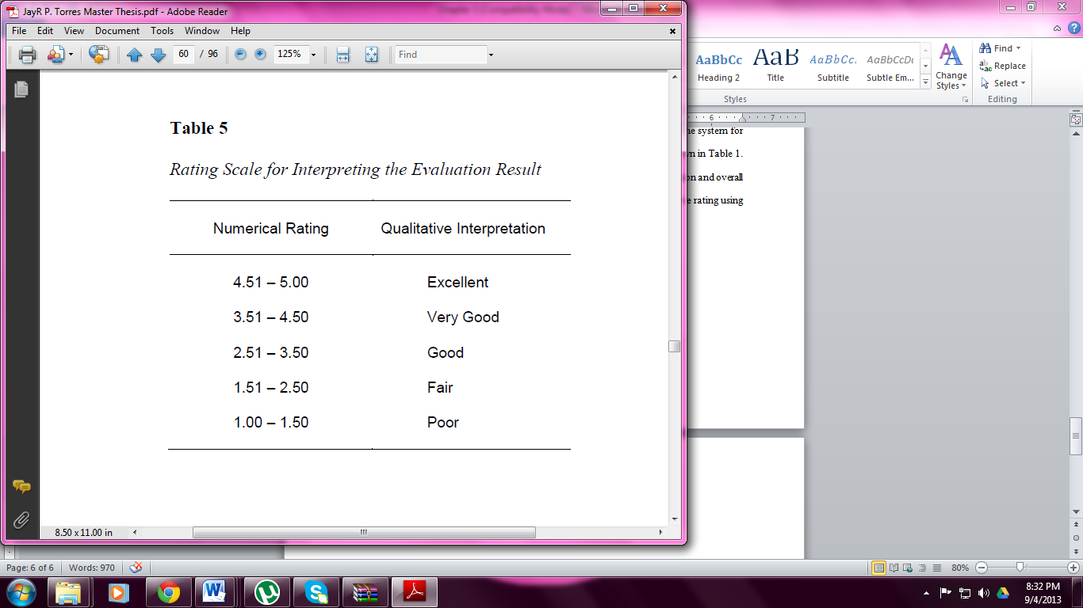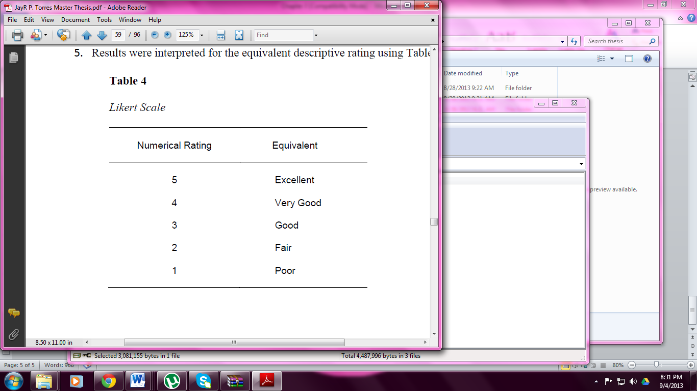 **Table 1 Table 2**